LAB PRACTICALS

1.FIBONACCI USING RECURSIVE.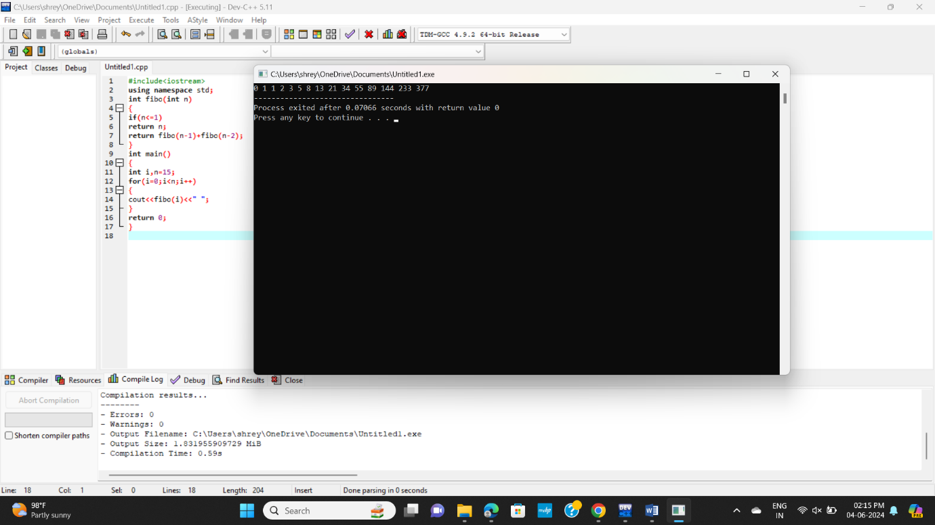

2.ARMSTRONG NUMBER.

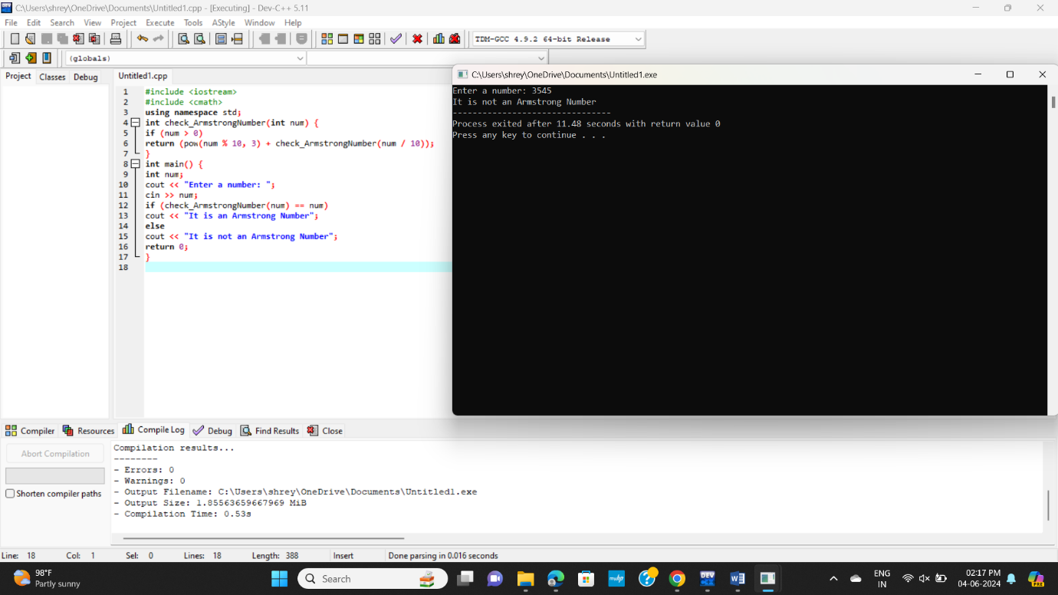

3.LARGEST NUMBER IN ARRAY

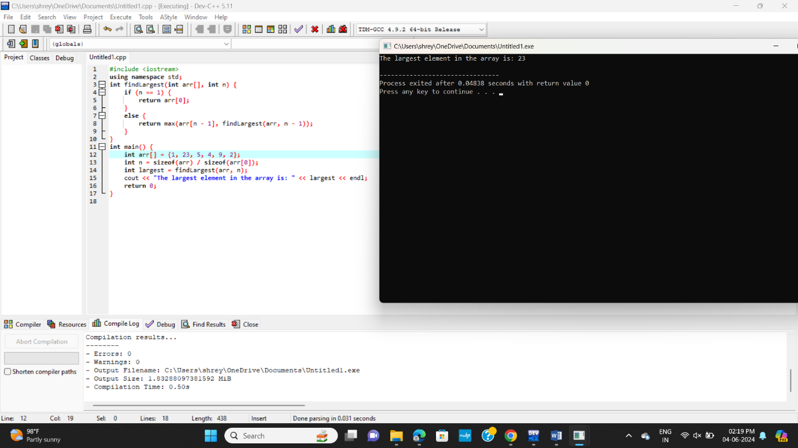

GCD OF TWO NUMBERS

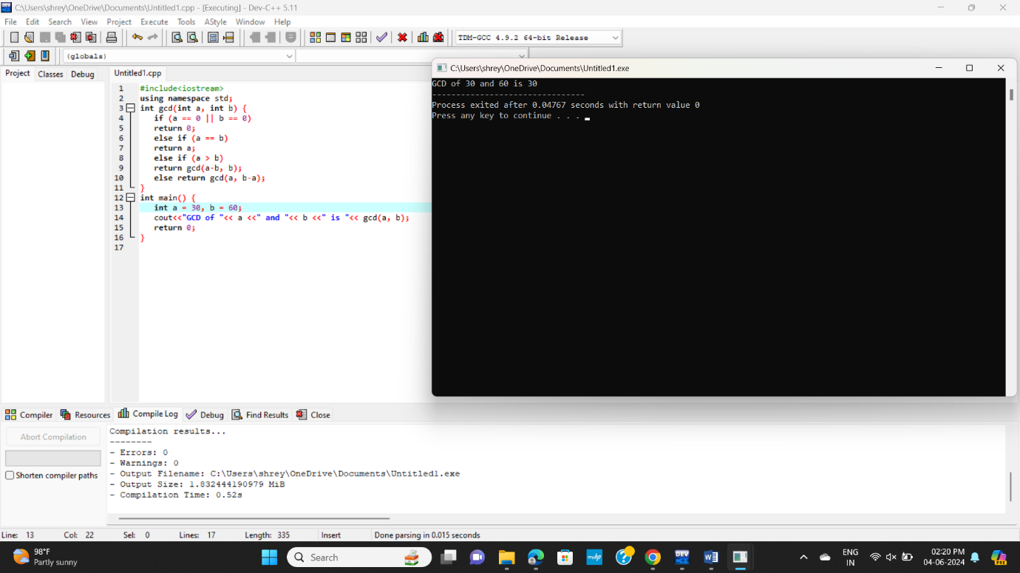

REVERSE OF STRING

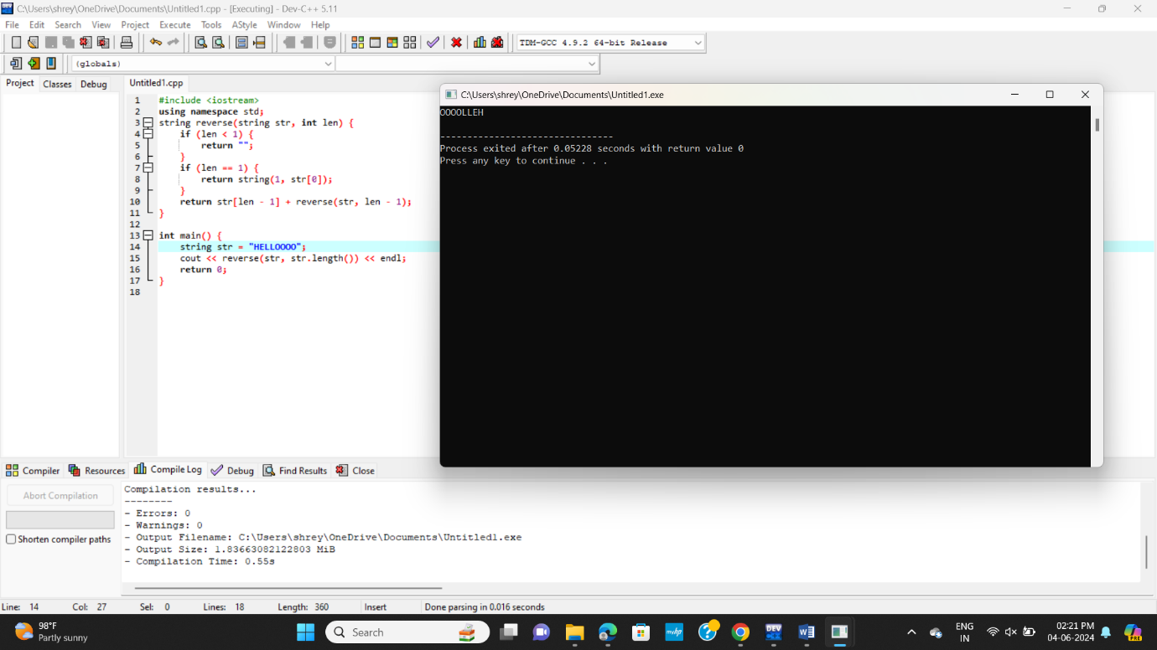

FACTORIAL

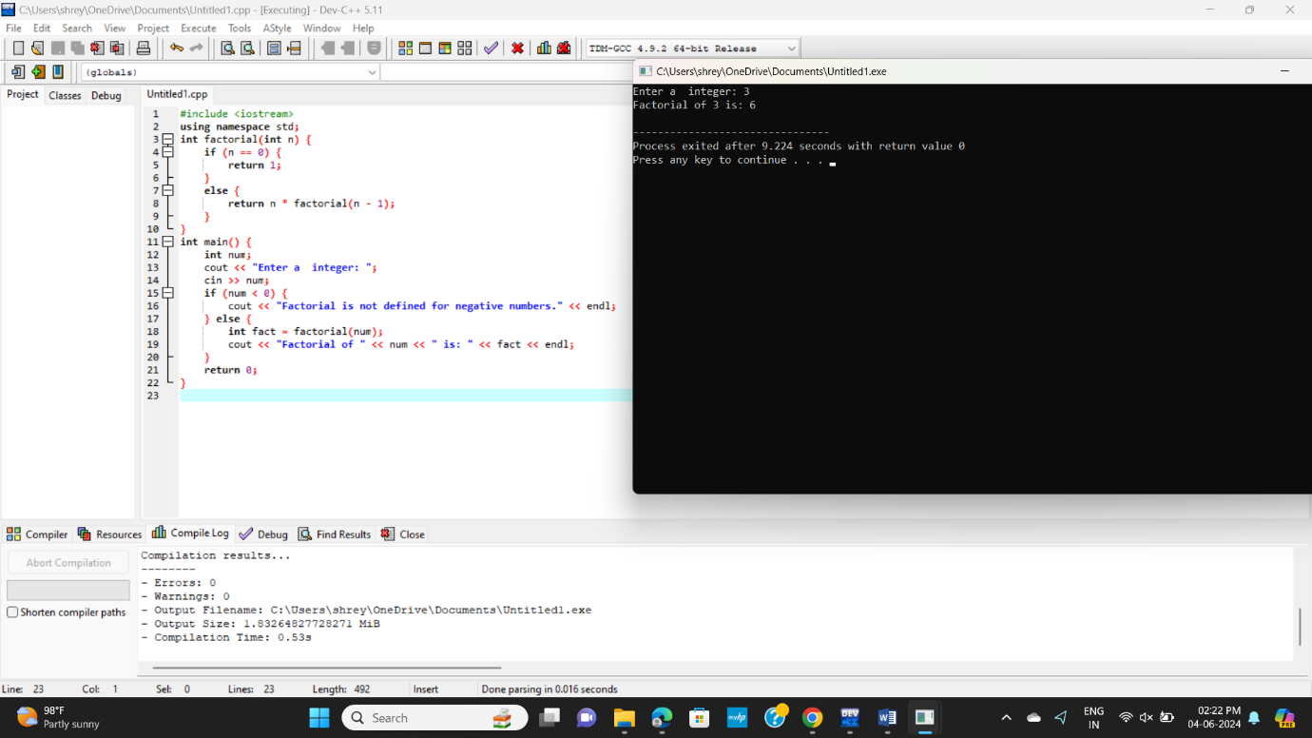

PRIME OR NOT

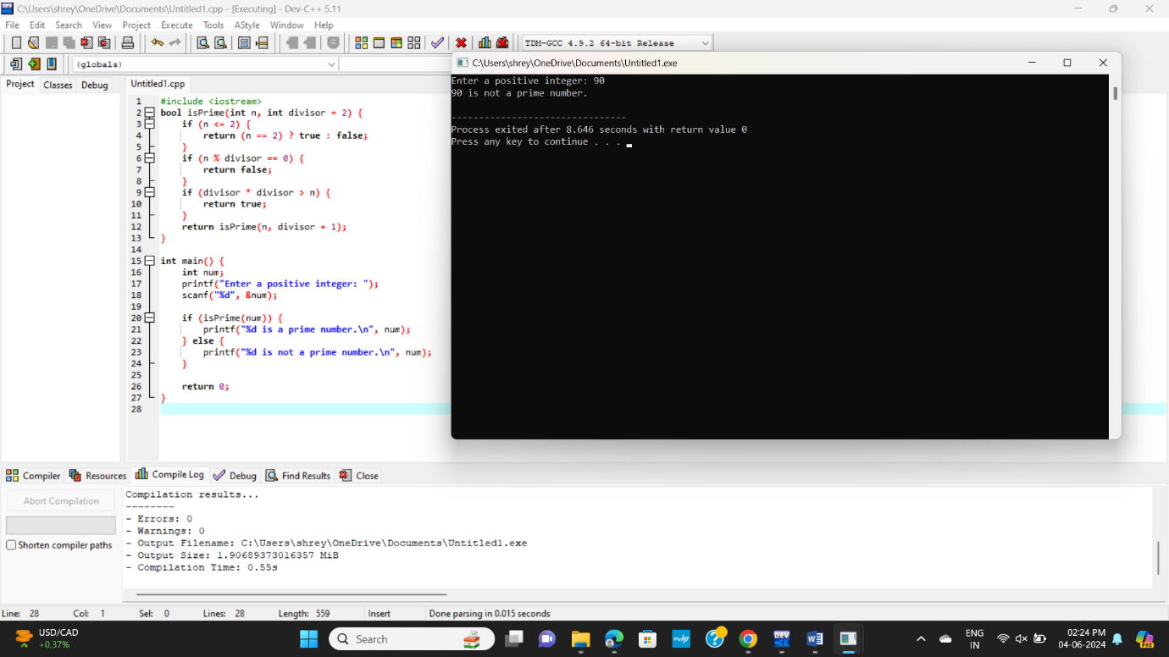

COPY ONE STRING TO ANOTHER

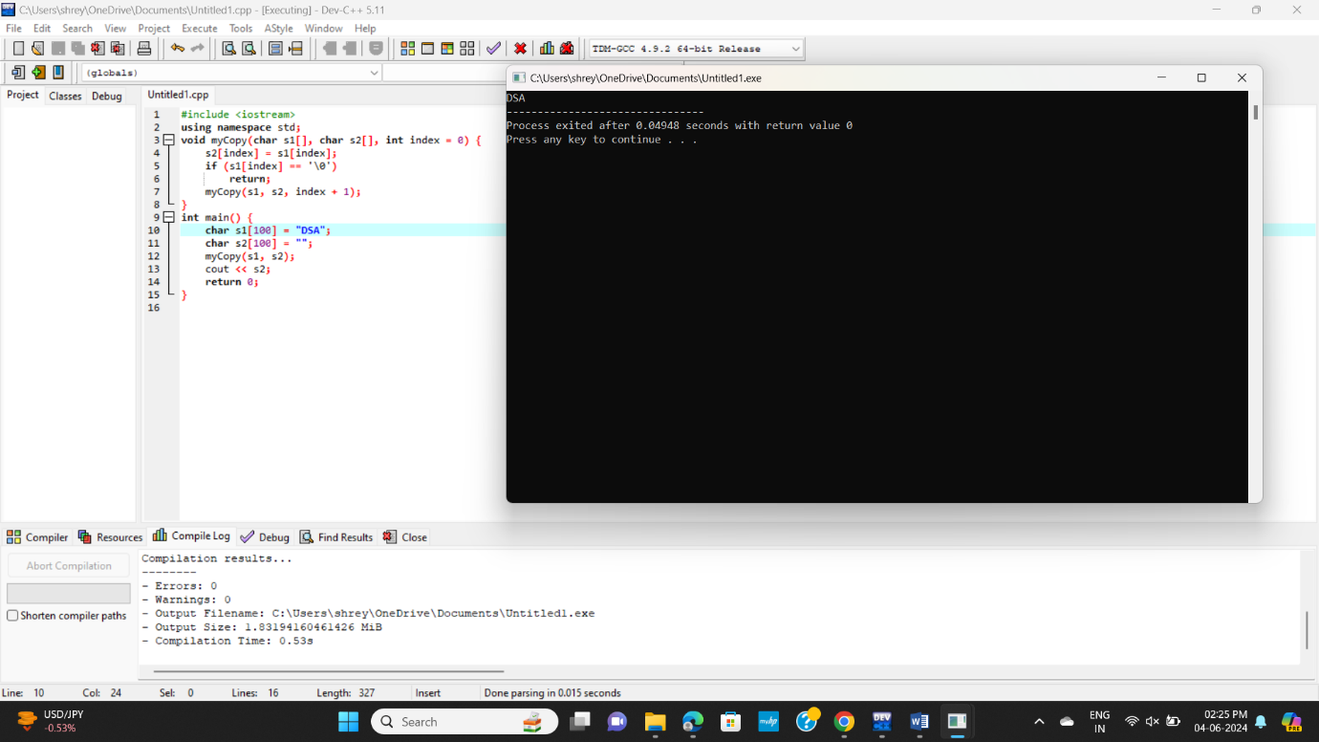

PALINDROME

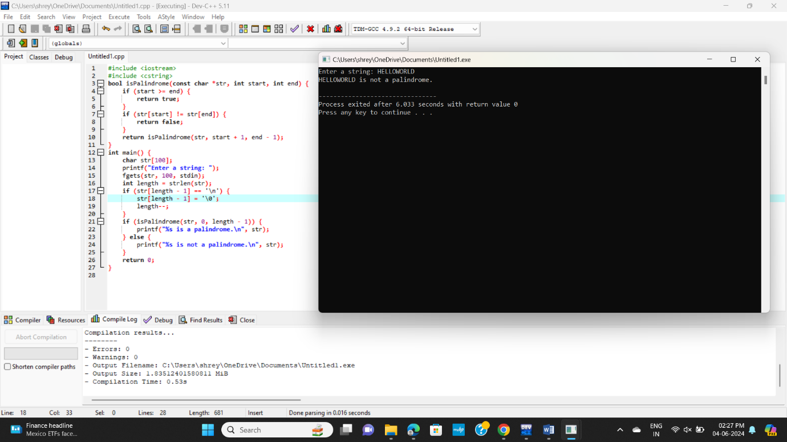

PRINT PRIME NUMBERS

